|  |
| --- |
|  |
| FLOOD MONITORING |
| AND EARLY WARNING |

Phase 3

Submitted by;

Gajjala Harsha Kesava Reddy

Au723921244020

harshagajjala122@gmail.com

Creating an IoT flood monitoring and early warning system involves several components and steps. I'll provide an overview of how you can start building this project:

Step 1: Define Project Requirements

Before you begin, it's essential to clarify your project's requirements, objectives, and the specific areas you want to monitor for potential floods. Identify the sensors and communication protocols you'll use, as well as the early warning mechanisms you'll implement.

Step 2: Select IoT Sensors

Choose appropriate sensors for measuring water levels in flood-prone areas. Options include ultrasonic sensors, pressure transducers, or even cameras for visual monitoring. Ensure the sensors are suitable for the environment and can withstand outdoor conditions.

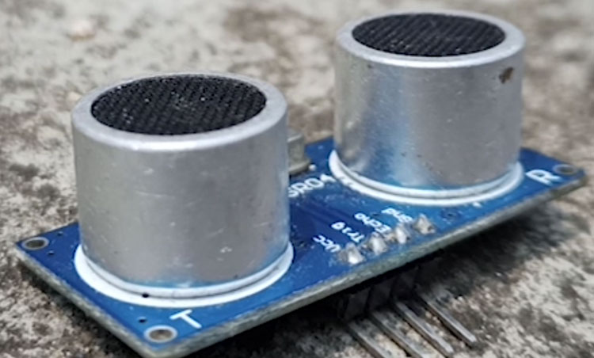

Step 3: Set Up IoT Hardware

1. Hardware Setup

- Connect the selected water level sensors to your IoT devices (e.g., Raspberry Pi, Arduino, ESP8266).

- Ensure the sensors are correctly powered and connected to the IoT device through GPIO pins or suitable interfaces.

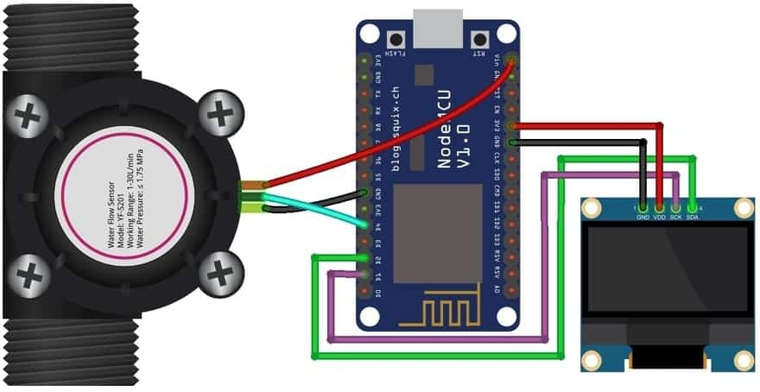

2. IoT Device Configuration:

- Install the necessary software and libraries for your IoT device.

- Configure the IoT device to connect to your local network or a cellular network, depending on the deployment location.

Step 4: Develop Sensor Software

Write a Python script to collect data from the water level sensors and transmit it to the central monitoring platform. The script should handle data acquisition and communication with the platform.

Here's a simplified example using a Raspberry Pi and Python:

# Import necessary libraries

import time

import requests # For HTTP communication

# Function to measure water level (replace this with your specific sensor code)

def measure_water_level():

# Implement your water level measurement logic here

return 42.0 # Replace with the actual water level value

# Main loop

while True:

water_level = measure_water_level()

# Send the data to the central monitoring platform (replace with your platform details)

data = {'water_level': water_level}

response = requests.post('https://your-monitoring-platform-url.com/api/data', json=data)

# Handle response if necessary

if response.status_code == 200:

print('Data sent successfully')

else:

print(f'Error sending data: {response.status_code}')

# Sleep for a defined interval (e.g., every 5 minutes)

time.sleep(300)

Step 5: Central Monitoring Platform

Develop or set up the central monitoring platform to receive, store, and analyze the data sent by IoT sensors. You can use a cloud-based platform or create your own server for this purpose.

- Design a database schema to store water level data along with location information.

- Implement data analysis algorithms to detect flood conditions or anomalies.

- Set up alerting mechanisms to notify relevant stakeholders when flood risks are identified.

step 6: User Interface

Create a user interface for visualizing the collected data and flood alerts. This can be a web-based dashboard or a mobile app, allowing users to monitor real-time data and receive notifications.

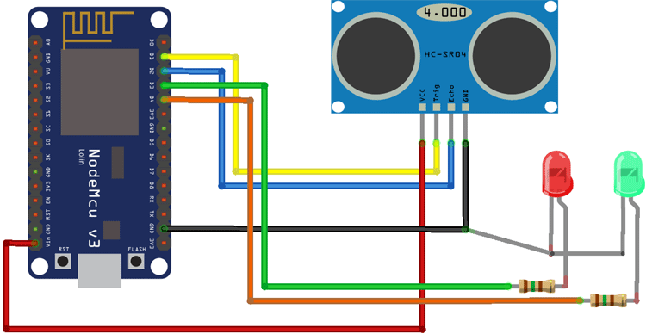

Step 7: Integration and Testing

Integrate all components, including IoT devices, the central monitoring platform, and the user interface. Test the system thoroughly to ensure it functions as expected.

Step 8: Deployment:

Deploy IoT sensors in flood-prone areas and ensure they are securely mounted and calibrated. Set up reliable power sources and communication methods.

Step 9: Continuous Monitoring and Maintenance:

Regularly monitor the system's performance, update software as needed, and maintain the hardware to ensure the system continues to operate effectively.

Remember that building an IoT flood monitoring and early warning system is a complex project that may require collaboration with experts in various fields, including IoT, data analysis, and meteorology.

References:

-internet,IBM,skillup online course